Issues for the RCHC Data Standards and Integrity Council
September 13, 2021 Meeting
Version 1, By Ben Fouts MPH, RCHC Data Analyst

- UDS Reporting of Visits for COVID-19 Screenings and Immunizations

Reports: 2021 UDS Report

Issue: Not all visits and patients with Covid-19 screening labs and/or Covid-19 vaccines are reported on the UDS. Health centers should research how Relevant classifies these patients and visits.

Description: The 2021 UDS Manual states that “not all individuals, encounters, and health center personnel will count in the UDS Report” (page 17) and so we have to be careful about what information from our EHR/Relevant is extracted to form the UDS patient population and the associated visit count and visit details. It is important to consider now, before we start looking at the 2021 UDS data and in light of the large amount of COVID information in the EHR.

Just as a quick review, unduplicated patients on the UDS Tables 3A, 3B, and 4 and the table for patients by ZIP Code must have had at least one visit in 2021 that meets the following definition (from page 17 of the manual): an encounter between a patient and a licensed or credentialed provider who exercises independent professional judgment in providing services that are documented, individual, and in-person or virtual.

The definition of a “provider” is on page 21 of the manual and a list of provider personnel appears in Appendix A (beginning on page 157). Once you have this group of patients, you can count visits (with providers and non-providers) on Table 5 and count patients and visits by diagnosis and procedure on Table 6A.

Now, let’s consider COVID screenings and vaccinations. These are not considered visits for the purpose of defining “health center patients” by the above definition. On page 20 of the manual there is a section titled “Services and Individuals Not Reported on the UDS Report” that states “Someone who only receives one of the services described below is not a patient for purposes of UDS reporting.” These services include “…Laboratory tests (including COVID-19…” and “…giving any injection (including for vaccines, COVID-19…”

In conclusion, people who only receive a COVID-19 lab test and/or a COVID-19 vaccine are not reported on the UDS or any of the clinical measures we report to other agencies, such as PHASE or PIP.

Therefore, health centers should do their own internal studies to see how visits for COVID-19 lab tests and COVID-19 vaccines are being handled in Relevant. All visits can be classified as UDS Universe Visits and UDS Medical Visits on the Relevant Importers “Visits” and “Visit Set Memberships.” Investigate if these visits are included in the UDS Universe and/or UDS Medical Universe.

These types of visits can be seen on the Relevant Visit Calendar as well. If you have particular visit types or designated “providers” for COVID labs vaccines, see if they are also in the UDS Universe and/or UDS Medical Universe.

Choose your visit types or providers:
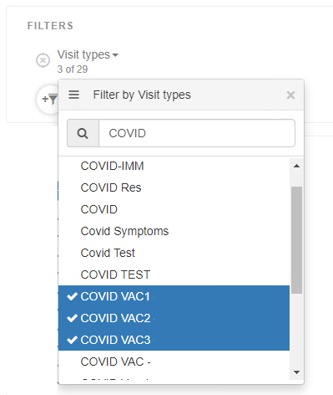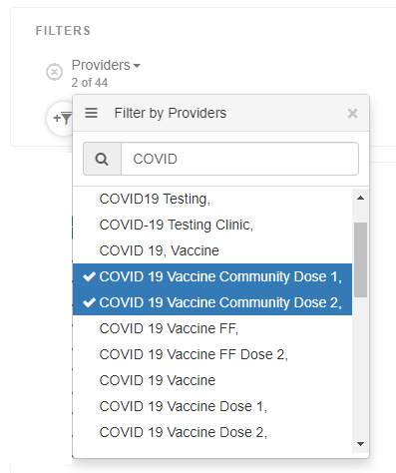

See if those choices produce any visits (this is an example from the RCHC Aggregate)
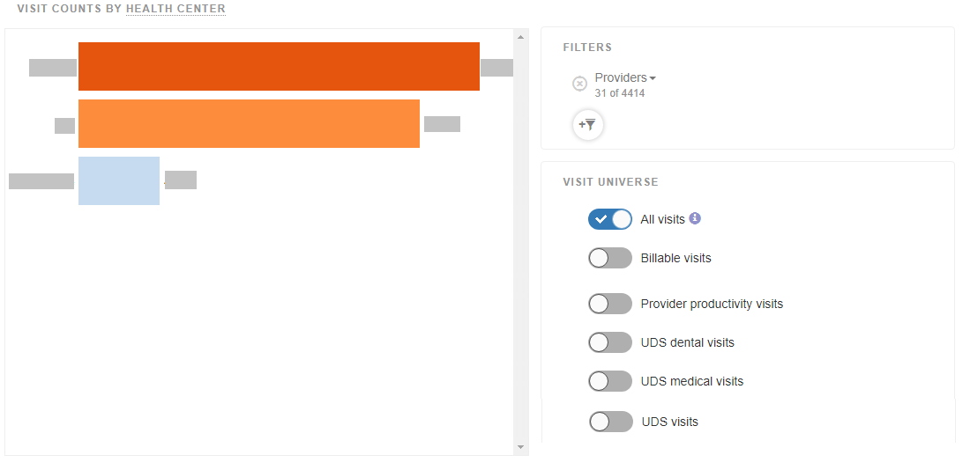
Then toggle the UDS visits button to see if those are classified in the UDS Visit Universe

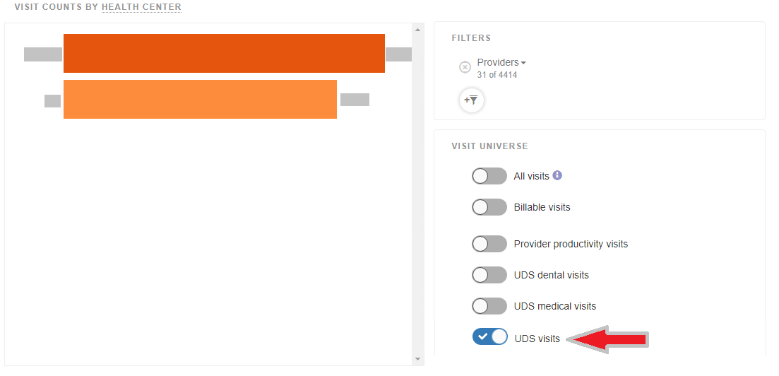

Then toggle the UDS medical visits button to see if those are classified in the UDS Medical Visit Universe
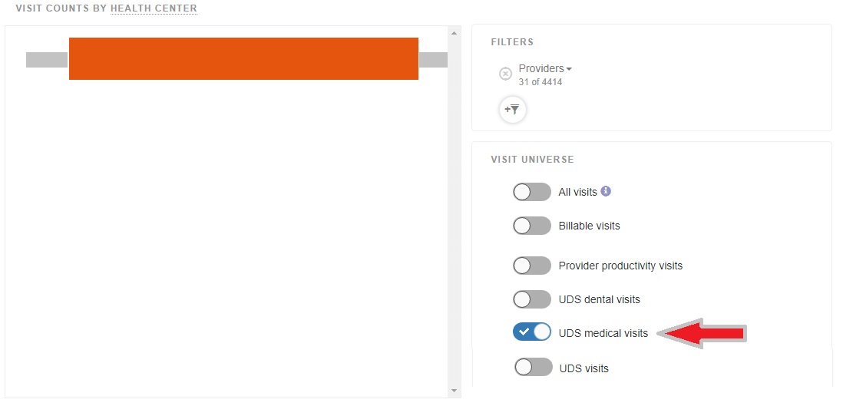

Right now, only do some research to see how these are classified in light of the UDS definitions. We are not recommending that any changes to Relevant be immediately performed without consulting your Relevant contact. The standard SQL in the UDS Report section of Relevant must also be considered for how patients and visits are being pulled and Ben has sent some questions to Relevant about this topic.

- Adding PHQ-2 and PHQ-9 Scores to the Relevant Standard Data Model

Reports: Partnership Data Exchange Files

Issue: Would health centers agree to add raw scores to depression screening Importer?

Description: The Importer for PHQ-9 screening (“phq9_and_phq9_m_screens”) has a field “result” that displays the numerical score of the screen.

PHQ-2 and other depression screening appear on the Importer “depression_screens.” This Importer has a result field, but this is a TRUE/FALSE field indicating if the screen is positive or not.

If we were to add the score to the Importer, we would also need to add the screening instrument. Although most health centers use the standard PHQ-2, there are other instruments in use and each one has a different numerical score indicating a positive result. The chart at the below shows some examples from a Partnership presentation.

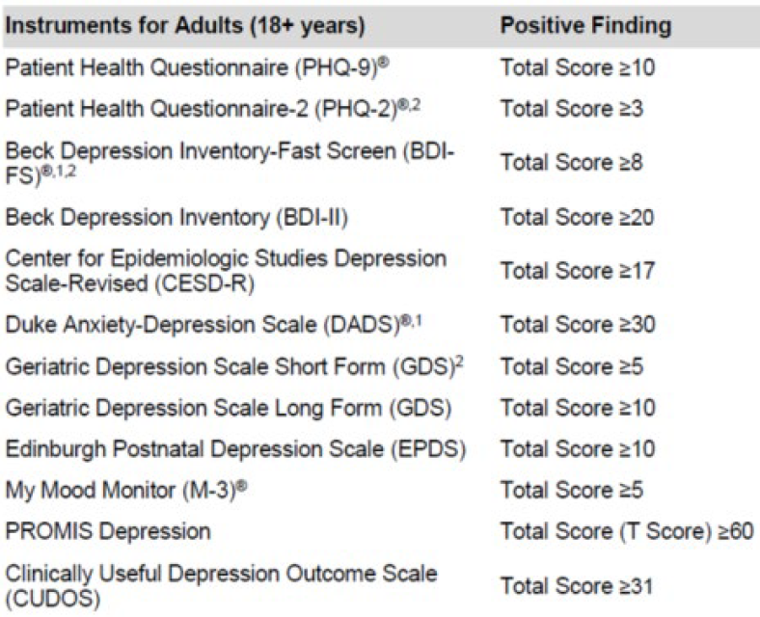

The Partnership QIP measures are an exception because they define and provide the denominator lists of patients. These patients may or may not have had a visit or any kind with the health center,

