Issues for the RCHC Data Standards and Integrity Council
May 3, 2021 Meeting
Version 1, By Ben Fouts MPH, RCHC Data Analyst

- 2021 UDS Measures

Reports: All UDS Quality Measures

Issue: Describe any changes to the UDS clinical measure set

Description: The 2021 UDS Instruction Manual is now available from HRSA. This manual is easier to read (compared to previous years) and contains updated language on issues like virtual visits and blood pressure readings that were in separate documents last year.

Ben read through the 2021 clinical measure descriptions and compared them to the 2020 definitions and 2020 UDS Quality Measures. He did not detect any differences or changes to be made. Therefore, no recommendations to Relevant are planned at this time.

If any health center identifies a change or has a question about a measure, please contact Ben directly (bfouts@rchc.net).

- 2021 Quality Measure and Value Set Availability in Relevant

Reports: All UDS and QIP Quality Measures

Issue: When should the 2021 Value Sets be loaded into Relevant?

Description: Although the logic and description of the UDS clinical measure set apparently did not change, there are always changes to the underlying Value Sets that define the diagnosis (ICD), procedure (CPT), lab (LOINC), vaccine (CVX) and medicine (RxNorm) codes for the measures. The 2021 code set is available now.

It is assumed that there will be a “2021” UDS Quality Measure set released by Relevant this year. Right now, RCHC does not have a projected date for when this may occur. Even though there are apparently not any major changes to the measures, Relevant may still revise the reports in some manner, perhaps to increase efficiencies, etc.

Should we request that Relevant load the new code set at the same time as they release the 2021 UDS Quality Measure set, or does any health center have a need for the Value Sets to be updated earlier? If the Value Set is updated, any enabled 2020 Quality Measure will use the 2021 codes instead of codes from 2020. This may not make much of a difference to the results (although this has not been directly tested), but as a group we should decide the appropriate course of action.

Furthermore, there are additional tables in Relevant for the CMS and HEDIS (QIP) Value Sets. Should these also be updated? Do any health centers use them?

- Geriatrics Workforce Enhancement Program (GWEP) Quality Measure Set Standardization

Reports: Four new Quality Measures

Issue: Numerator elements need to be standardized for the measures and a decision made on the best way to display results

Description: RCHC and ten health centers (AVH, CommuniCare, Marin City, MCC, Ole, PHC, Ritter, Santa Rosa, Sonoma Valley and Winters) are participating in a collaborative with UCSF that focuses on providing education and innovative services that address older adults’ health, social, and legal needs.

There is a data-gathering component of the program that includes four measures on patients 65 years and over seen at the health center.

Measure Name | Numerator Definition | EHR Standardization
Use of High-Risk Medications in the Elderly | Patients who have one or more (or two or more) high risk medications on their current medication list | No standardization needed as a new Transformer in Relevant identifies the medications by name
Screening for Future Fall Risk | Patients who were screened for future fall risk at least once within the measurement period | Probably best as a structured data item (HPI?)
Care Plan | Patients who have an Advance Care Plan or surrogate decision maker documented in the medical record or documentation in the medical record that an Advance Care Plan was discussed but patient did not wish or was not able to name a surrogate decision maker or provide an advance care plan | eCW features a standard location for entering the type of Advance Care Plan, what it contains and if it was discussed with the patient.  No NextGen health center has the Importer set-up (see discussion below)
Education and Support of Caregivers for Patients with Dementia | Patients with dementia whose caregiver(s) were provided with education on dementia disease management and health behavior changes AND were referred to additional resources | This measure is completely new. Three possible data elements might be best entered into structured data (HPI?)

The goal is to place these measures in the RCHC Aggregate instance. Therefore, appropriate Transformers and Importers would need to be established for the participating health centers who do not already have them. Furthermore, health centers can choose if they prefer a Quality Measure to display results in their own instance of Relevant.

Discussion: Some health centers already have experience gathering the above data, so we can learn from them. Otherwise, the DSIC can decide on the most appropriate method of data gathering.

Screening for Future Fall Risk

This was an old measure and four health centers (of ten in the collaborative) have already established a Transformer to gather the data from HPI. There is no standard Importer for fall risk in the Relevant schema.

Although Transformers can have custom names, it is suggested that the name for health centers newly establishing it should contain the text “…fall_risk…” (for example, rchc_fall_risk).

The recommended structured data elements are:
- The question can go under any HPI category, but the question should be named “Fall Risk Assessment:”
- The options for data entry are:
- No falls in the past year
- One fall with injury in the past year
- One fall without injury in the past year
- Two or more falls with injury in the past year
- Two or more falls without injury in the past year

Care Plan

This is a current QIP Unit of Service measure and eight (of ten in the collaborative) health centers have established an Importer to gather the data.

There is a standard Importer named “Advance Care Plannings” that is used to gather the data. Although Transformers can have custom names, it is suggested that the name for health centers newly establishing it contains the text “…advanced_care…” or “…adv_care…” (for example, rchc_adv_care_planning). Alternately, the Importer can contain the SQL code to gather the data directly.

Because all of the health centers with an established Importer use eCW, it is unknown if there is a standard way that NextGen health centers enter Advance Care Plans. We would like to hear from the health centers using NextGen how they are entering Advance Care Plans. In eCW, there is an area to enter this data. In Relevant, there is a corresponding table (pt_adv_directives) that displays the data. It looks like there is a Code field and a Name field associated with the Advance Care Plan entered. Two eCW health centers have structured data elements for Advanced Care Plans and discussions (HPI or Preventive sections) linked to their Importer.

To count for the numerator, there must be an Advance Care Plan or surrogate decision maker documented in this section of the medical record. If none is entered, documentation of a discussion around care planning or that the patient declined is necessary.

Below are some examples of the Code and Name fields that can be appropriate for documenting an Advance Care Plan:
Code | Name
ADV DIR | Advanced directive on file
AIM | Advanced Illness Management
COMFORT | Comfort Care Only (Includes DNR/DNI)
DNAR | Do not attempt resuscitation
DNI | Do Not Intubate
DNR | Do Not Resuscitate
DNR/DNI | Do not resuscitate/Do not intubate
DPA | Durable Power of Attorney docs filed in patient docs
FULL | Full Code
HOSPICE | Patient is under hospice care
NO BLOOD | No blood transfusions
ON FILE | See full advanced directive in patient documents
POA | Power of Attorney
POLST | POLST form completed see patient documents
SELECTIVE | Selective medical care dependent on discussion with the patient or family
TRIAL | Trial period of artificial nutrition, including feeding tubes.

Below are some examples of the Code and Name fields that can be appropriate for documenting a discussion (and refusal, if that occurred) around an Advanced Care Plan:
Code | Name
CONVERSE | Additional discussion with patient
CONV OFF | Conversation offered, patient declined
CONV-FU | Conversation initiated, follow up planned
DECLINED | Pt declined to fill out AD; revisit at future visit
DENIED | Pt declined to fill out AD; revisit at future visit
DISCUSSED | AD/POLST d/w pt. Pt given info and/or form to take home
FORMS | Forms given to patient
REFUSAL | Patient Refusal

No matter the EHR type, it is suggested that health centers have the ability to document the existence of an Advanced Care Plan and also what type it is or other important details of the contents. Furthermore, the discussion and outcome of the discussion should be documented when a Care Plan is not completed at the time.

Note that the Partnership QIP Unit of Service Measure provides funds for health centers who document the adoption of an Advance Directive and/or POLST, or a discussion around planning one. This includes conversations with patients who already have an Advance Directive and/or POLST but do not wish to make changes, as well as conversations stressing the importance of completing one. RCHC is developing a report for the 2021 QIP Report Set that lists all Care Planning activities from the Importer named “Advance Care Plannings” so that the health center can enter these conversations into the eReports template (when appropriate). See the measurement requirement in the 2021 Primary Care Provider
Quality Improvement Program Specifications for further detail.

Education and Support of Caregivers for Patients with Dementia

This is a new measure, so no standard data entry practices exist. It seems like this kind of data might best be entered into structured data, like HPI. Three data items are needed:
- Identification of Caregiver(s), or documentation that the patient does not have a Caregiver. [Note: a “Caregiver” refers to any relative, partner, friend, or neighbor who has a significant relationship with, and who provides a broad range of assistance for, an older adult or an adult with chronic or disabling condition.]
- Caregiver(s) were provided with education on dementia disease management and health behavior changes.
- Caregiver(s) were referred to additional resources [“Additional Resources” are defined as situation-specific, tailored programs to assist the caregiver; these included national organizations such as the Alzheimer’s Association, but also include local resources, such as community, senior center and religion-based support groups.]

Below is an example of a Template for Education and Support of Caregivers for Patients with Dementia.

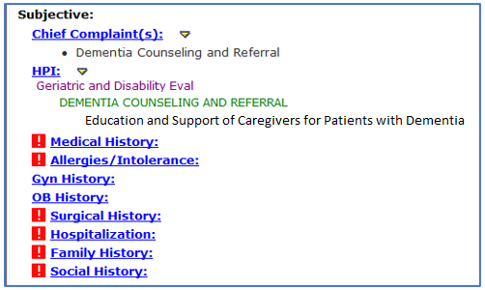
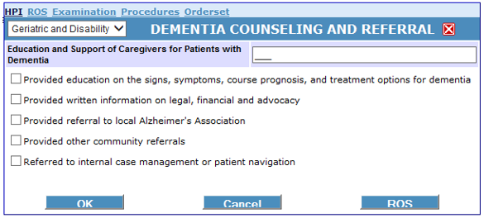

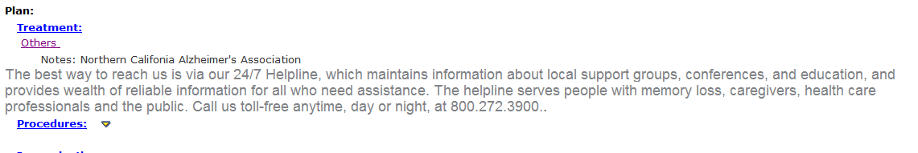

The measure has an exclusion for patients who do not have an identified Caregiver, or patients who have a Caregiver who is already trained and certified in dementia care. Therefore, one idea might be to add options for these into the pick list.

Link: https://bphc.hrsa.gov/datareporting/reporting/index.html

