Issues for the RCHC Data Standards and Integrity Committee
October 1, 2018 Meeting
Version 1, By Ben Fouts MPH, RCHC Data Analyst

- Exclusion Definition vs Exception Definition

Report: All reports that have exceptions defined in the eCQM

Issue: The 2018 UDS instructions do not define the difference between denominator “exclusions” and “exceptions” in the sections titled “Exclusions/Exceptions” under each measure. The technical eCQMs referred to in the UDS instructions distinguish the exclusions from the exceptions. Should our electronic reports also recognize this difference?

Definitions:

- Denominator Exclusion. Is a subset of the denominator. Exclusion specifications remove patients/events from the denominator who meet specific criteria that make it clinically unnecessary for the patient to receive the numerator clinical action.
- Denominator Exception. Is a subset of the denominator. Exception specifications remove patients/events from the denominator only if the numerator criteria are not met. Exceptions are generally provider or patient determined reasons for refusing certain clinical actions.

Additional Information:

Measures that have at least one exception are listed in the table below. For all other measures, the description under the heading “Exclusions/Exceptions” in the UDS instructions is an exclusion.

UDS Measure | Exclusions | Exceptions
Screening for Depression and Follow-Up Plan | Patients with an active diagnosis for depression or a diagnosis of bipolar disorder | - Patient refuses to participate  - Patients with a documented medical reason (such as an urgent or emergent situation)  - Situations where the patient's functional capacity or motivation to improve may impact the accuracy of results of standardized depression assessment tools.
Body Mass Index (BMI) Screening and Follow-Up Plan | - Patients who are pregnant  - Patients receiving palliative care  - Patients who refuse measurement of height and/or weight or refuse follow-up | Patients with a documented medical reason, such as:  - An urgent or emergent situation  - Elderly Patients (65 or older) for whom weight reduction/weight gain would complicate other underlying health conditions such as the following examples:  - Illness or physical disability  - Mental illness, dementia, confusion  - Nutritional deficiency, such as Vitamin/mineral deficiency
Tobacco Use: Screening and Cessation Intervention | None | Patients with a documented medical reason for not screening for tobacco use or for not providing tobacco cessation intervention for patients identified as tobacco users (e.g., limited life expectancy, other medical reason)

- Patients Declining Depression Screens or Followup

Report: Screening for Depression and Follow-Up Plan

Issue: The 2018 UDS instructions allow a denominator exception for patients who “refuse to participate” (page 95). Can we agree that health centers can document patients who decline to be screened for depression or decline any kind of follow-up activity and that this would count as an exception to the denominator?

Description: eCW Version 11 contains changes to the depression screening and followup templates. One change is that they are allowing the user to enter that a patient declines screening. Because not all health centers have version 11 yet (and Ben has not tested it), we do not have all the details. Some health centers have also built this option into structured data. In any case, this should be something built into the measure for whatever health record or reporting system you use.

- The Timing of Positive Depression Screens

Report: Screening for Depression and Follow-Up Plan

Issue: For patients who are screened multiple times during the measurement period, which screenings should be examined by the report?

Description: Patients with several visits can be screened for depression several times, with potentially a mix of results. Below is a hypothetical situation. How should the depression measure be evaluated for this patient?

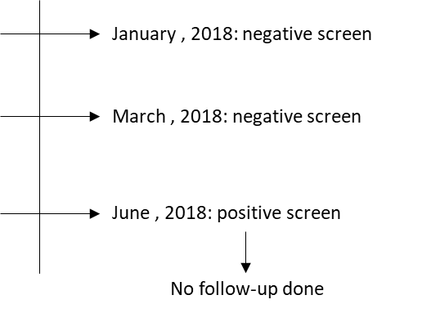

- Option #1: the patient should not be included in the numerator because there was no follow-up to the first positive screen in the 2018 measurement period.
- Option #2: the patient should be included the numerator because the patient was screened in the measurement period and the first screen was negative.

- Adult Weight Exclusions and Exceptions

Report: Adult Body Mass Index (BMI) Screening and Follow-Up Plan

Issue: The Adult BMI and Follow-up measure has multiple exclusions and exceptions. Can we agree that the proposed measure logic makes sense and is consistent with clinical guidelines?

Description: The definitions are on the first page of the attachment (titled “Definitions For Preventive Care and Screening: Body Mass Index (BMI) Screening and Follow-Up Plan”).

Additional Information: The logic plan is on the second page of the attachment (titled “Proposed Logic For Adult Body Mass Index (BMI) Screening and Follow-Up Plan”)

