eHX for Providers – get records from other health centers
- Access the eHX tab from the right chart panel
- Use the arrows to add diagnoses, allergies, medications and history to our chart
- For more information (labs, DI, OB flow) click the orange stripe that says “Click here to view Patient eHX Summary”
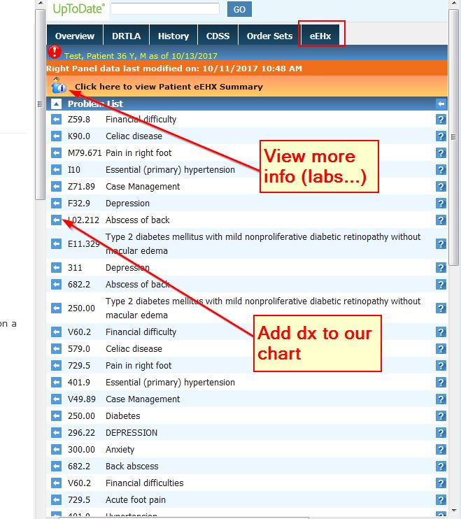
- If the patient is a health center patient (SRCHC, CHA, WCHC, OLE, RITTER, AVMC, Marin City) and information is not on the eHX tab. Try searching the eHX Window.
- Use the Tools menu on the top of the screen and choose Launch eHX browser.
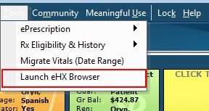
- Click patient lookup and search for your patient last name,first name.
- You may note more than one record for your patient – LOOK AT BOTH
- You may be asked to provide a reason for accessing the account. Please select emergency care.
