HOW TO…………
Check Rx eligibility when sending medications via a TE

From telephone encounter Rx Tab
- Click the Rx Eligibility button
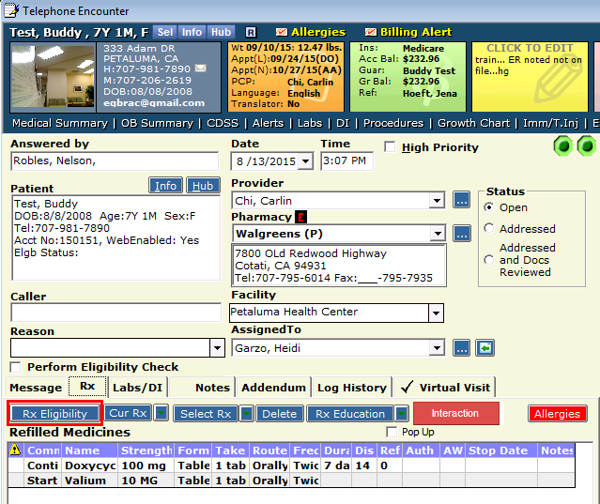

On Rx Eligibility window
- Click the Rx eligibility button
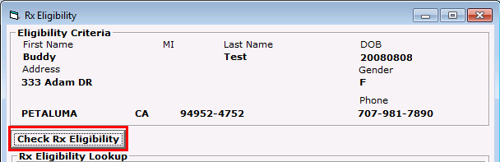

Once the Rx eligibility has been checked.
- Select the payer from the Rx eligibility lookup and click set Formulary
- Then Close window and send Rx
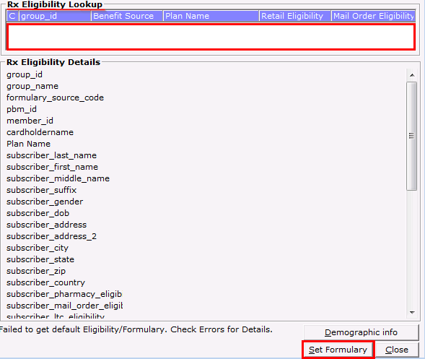

- When once the Rx eligibility has been checked. If there is no payer listed
- Click Close
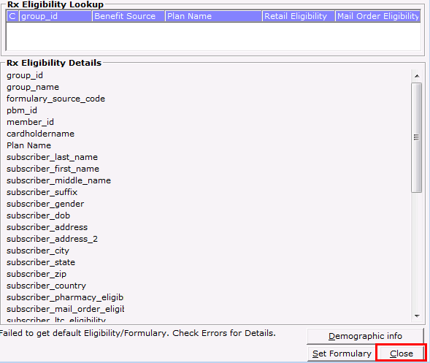

- From TE tabs, Click the green arrow next to Current Rx, and select External Rx History
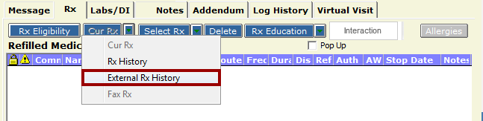

- Click Retrieve Rx History

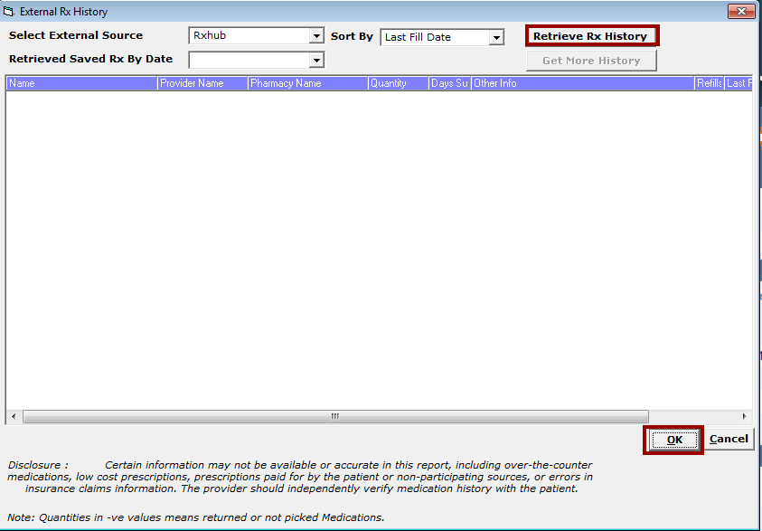

- Click OK

