Marin Opioid Overdose Snapshot: 2014-Q1 to 2016-Q4
Marin experienced 13 deaths due to all opioid-related overdoses in 2016, the most recent calendar year of data available. The annual crude mortality rate during that period was 5 per 100k residents. This represents a 335% increase from 2014. The following charts present 12-month moving averages and annualized quarterly rates for selected opioid indicators. The map displays the annual zip code level rates for all opioid-related overdoses. Synthetic overdose deaths are likely to be largely represented by fentanyl.
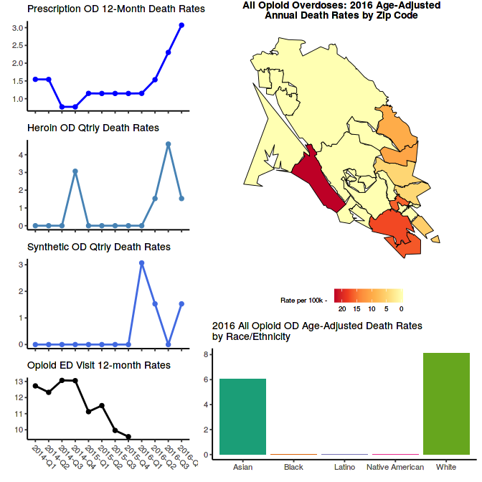

Prescribing
There were 153,706 prescriptions for opioids in Marin in 2016, excluding buprenorphine. The annual prescribing rate during that period was 589.7 per 1,000 residents. This represents a 7% decrease in prescribing from 2014. The following charts present the annualized quarterly prescribing rates, MMEs (morphine milligram equivalents) per person per year, high dosage rate (i.e. greater than 90 Daily MMEs in the quarter), and the opioid/benzodiazepine overlap rate during 2016.
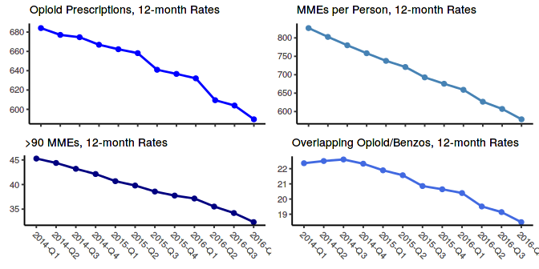

Treatment
Buprenorphine prescriptions in the county are used to gauge the expansion of medication-assisted treatment (MAT). The annual buprenorphine prescribing rate in 2016 was 26.2 per 1,000 residents. This represents a 4% increase in buprenorphine prescribing from 2014.
